# Absolute and Relative Paths

## Assignment Objectives:

On completing this lab, you should be able to:

* Use absolute path notation to work with files in the Command Line.
* Demonstrate using Relative Path to work with files and folders in the Command Prompt environment.

## Part 1 - Set up

Before you begin Part 1, you will need to perform some preparation:

### Step 1

Read the handout in Virtual Lab folder in Blackboard for this class to access your stu##-ubu virtual machine. Log in to the **sysadmin** account with the password **netlab123** and open the terminal program.

### Step 2

**Download the script1.sh and CA.zip file to your virtual machine. There are 2 options you can try.**

**Option 1**

In your virtual machine you can try opening Firefox and navigate to Canvas and download the script1.sh or CA.zip files attached to this assignment. If this doesn’t work, try option 2.

**Option 2**

**In your Windows or home computer (not the VM)** download the **script1.sh** and the **CA.zip** file associated with this assignment in Canvas. Then upload those files to Google Drive or Office365 or email them to yourself so you can access them in the virtual machine.

**In your virtual machine** open firefox and go to wherever you saved the script1.sh and CA.zip file online (Google Drive, Office365 or email) and download the files to the virtual machine. The file should download and be saved in your Downloads folder on your virtual machine.

### Step 3

Open the file manager in the Downloads folder. Right-click on the script1.zip file and select Extract Here. Once extracted you should have a script1.sh file.

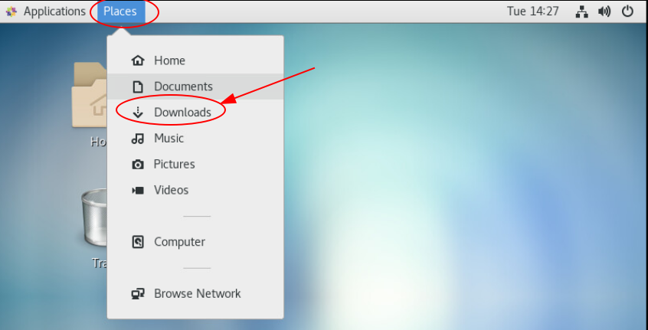

Right-click on the script1.zip file and select Open with Archive Manager. Once extracted you should have a script1.sh file.

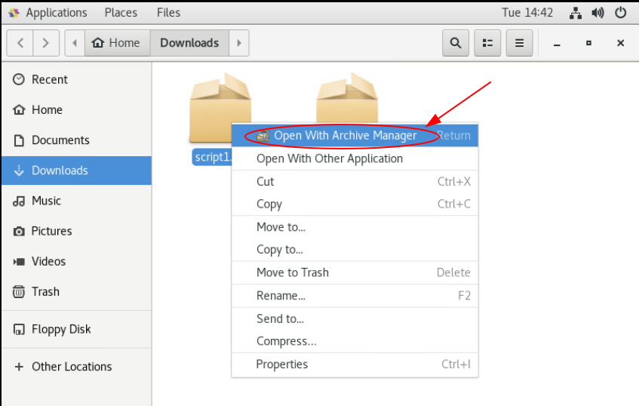

Then click Extract in the top left corner and then again in the top right corner to unzip the file.   
  
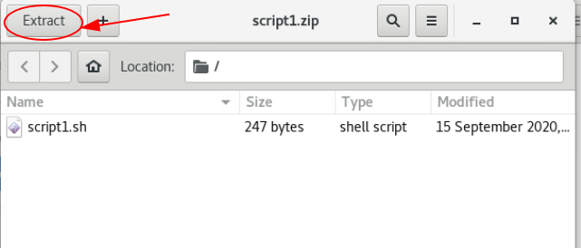  
  
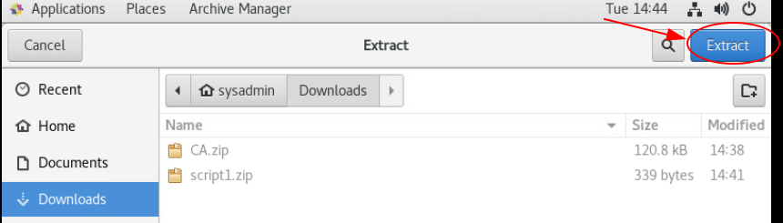  
  
Once completed, close the window.

### Step 4

In your terminal.

1. Type: **cd Downloads**, to change to the Downloads directory.
2. Type the **ls** command to verify you correctly downloaded the CA.zip and script1.zip files.
3. Type: **bash script1.sh**, to extract and move all the files and directories in the CA.zip file.

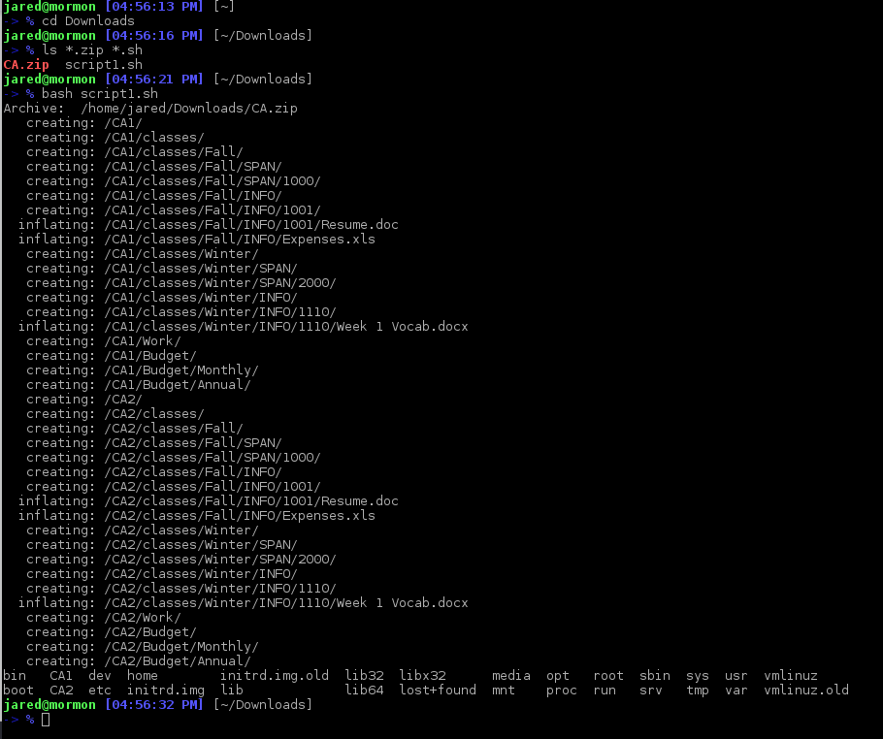

*Continued on the next page.*

## Part 2 - Absolute Paths

### Task Overview

Using the directory structure shown below as a reference, enter an **absolute path** or the command to complete the task. **NOTE**: begin by moving to the / directory by typing: cd / . You can then move into the /CA1 directory.

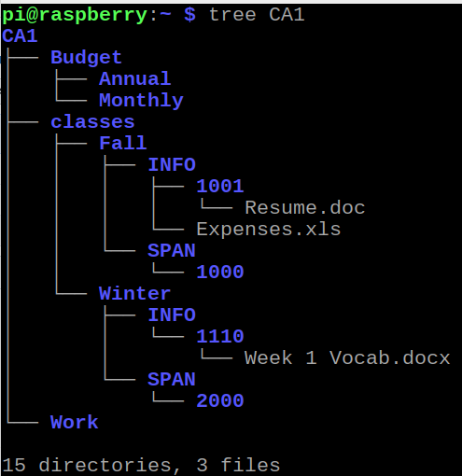

Remember these three important tips:

1. Absolute paths ALWAYS begin with a forward slash ( / ).
2. Each directory at each level of the path is separated by at forward slash ( / ).
3. Linux is case sensitive so a lower case d is not the same as an uppercase D.

Enter the **absolute** path for the following:

**Task 1:**  Enter the **absolute path** for the Resume.doc file?

| **Answer** |
| --- |
|  |

**Task 2:**  Enter the **absolute path** for the Expenses.xls file?

| **Answer** |
| --- |
|  |

**Task 3:**  Enter the **absolute path** for the “Week 1 Vocab.docx” file? (Use double quotes since the file name has spaces.)

| **Answer** |
| --- |
|  |

**Task 4:**  Enter the **absolute path** for the Work directory?

| **Answer** |
| --- |
|  |

**Task 5:**  Enter the **absolute path** for the Annual directory?

| **Answer** |
| --- |
|  |

**Task 6:**  Enter the **absolute path** for the 2000 directory?

| **Answer** |
| --- |
|  |

**Task 7:**  Enter the **absolute path** for the **SPAN child directory** under the **Fall** parent directory?

| **Answer** |
| --- |
|  |

## Part 3 - Using Absolute Paths with Commands

Using the directory structure shown above as a reference, enter a **single** command needed to accomplish the task using **absolute paths.** You are provided a Current Working Directory, however your location on the filesystem doesn’t really matter for absolute paths. **NOTE**: begin by moving to the / directory by typing: cd / . You can then move into the /CA1 directory.

Below is an example of the next part of this assignment. Each Task of this part of the lab consists of a task**.** Enter the command that would do that task in the **Your Answer** area. It is **highly recommended** that you attempt these commands on your virtual machine to verify that your answer works and is correct. You will be using the ls, mv, cp, cd, mkdir commands.

**Example:** Using **absolute path** notation, list the contents of the **1001** directory.

| **Current Working Directory** | **Your Answer** |
| --- | --- |
| /CA1/Classes/Winter/INFO/1110 | ls /CA1/Classes/Fall/INFO/1001 |

Explanation:

1. Your Current Working Directory does not matter for absolute paths.
2. The ls command list the contents of directories.
3. /CA1/Classes/Fall/INFO/1001 is the path location of the directory.

*Continued on the next page.*

### Task

**Task 8:**  Using **absolute path** notation, ***list*** the contents of the **1110 directory.**

| **Current Working Directory** | **Your Answer** |
| --- | --- |
| /CA1/Budget/Annual $ |  |

**Task 9:**  Using **absolute path** notation, ***move*** **Resume.doc** from the **1001** directory to the **Work** directory. **NOTE:** Since the mv command used 2 paths, both need to be absolute paths.

| **Current Working Directory** | **Your Answer** |
| --- | --- |
| /CA1/Budget/Annual $ |  |

**Task 10:** Using **absolute path** notation, ***copy***the **“Week 1 Vocab.docx” file**  to the **2000 directory.**

**NOTE:** Remember to use double quotes because this file name contains spaces.

| **Current Working Directory** | **Your Answer** |
| --- | --- |
| /CA1 $ |  |

**Task 11:** Using **absolute path** notation, **create a new directory** named **Resources** inside the **Classes** directory.

| **Current Working Directory** | **Your Answer** |
| --- | --- |
| /CA1/School/Fall/SPAN $ |  |

**Task 12:** Using **absolute path** notation, ***copy*** **Resume.doc** from the **Work** directory to the new **Resources** directory.

| **Current Working Directory** | **Your Answer** |
| --- | --- |
| /CA1/School/Fall/SPAN $ |  |

**Task 13:** Using **absolute path** notation, *copy* **Expenses.xls** to the **2000** directory.

| **Current Working Directory** | **Your Answer** |
| --- | --- |
| /CA1 $ |  |

**Task 14:** Using **absolute path** notation, *move* the copied **Expenses.xls** file you created from Task 13 (in the 2000 directory) to the **Monthly** directory.

| **Current Working Directory** | **Your Answer** |
| --- | --- |
| /CA1/School/Winter $ |  |

**Task 15:** Using **absolute path** notation, ***change your working directory***to the**1000** directory. **NOTE:** After performing this task, you can use the pwd command to verify you completed this task correctly.

| **Current Working Directory** | **Your Answer** |
| --- | --- |
| /CA1/School/Winter $ |  |

*Continued on the next page.*

Checking Your Work

Once complete, you can check your answers by doing the following.  **(OPTIONAL)**

1. In your command prompt window, type: “tree /CA1” and press Enter.
2. If the tree program is not installed, use the command “sudo dnf -y install tree”. You will be prompted to enter a password. Enter the “netlab123” password. **NOTE:** Your cursor will not move and it will look like your password is not typing, but it is. Trust me.

## Part 4 - Relative Paths

### Task Overview

Using the directory structure shown below as a reference, enter an **Relative path** or the command to complete the task.

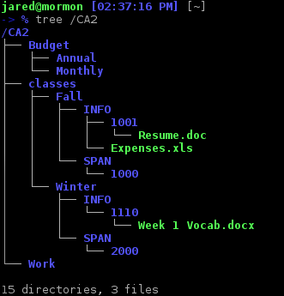

Remember these three important tips:

1. Relative paths **NEVER** begin with a forward slash ( / ).
2. Relative paths **ALWAYS** begin with either the **name** of the file or directory or either **1 dot** (.) or **2 dots** (..).
3. When going down a path use the name of the file or directory. Remember each directory at each level of the path is separated by at forward slash ( / ).
4. When moving up a path use 2 dots (..).
5. Linux is case sensitive so a lower case d is not the same as an uppercase D.

Use the directory structure shown above as a reference, enter a **single** command needed to accomplish the task using **relative paths.** Knowing your current working directory is important when working with relative paths. Your command prompt will help identify your current working directory or you can use the pwd command.

Below is an example of the next part of this assignment. Each Task of this part of the lab consists of a task**.** Enter the command that would do that task in the **Your Answer** area. It is **highly recommended** that you attempt these commands on your virtual machine to verify that your answer works and is correct. You will be using the ls, mv, cp, cd, mkdir commands.

**Example 1** : Using **relative path** notation, **list** the contents of the **2000** directory.

| **Current Working Directory** | **Your Answer** |
| --- | --- |
| /CA2/Classes/Winter/INFO/1110 $ | ls ../../SPAN/2000 |

**Explanation:**

1. Notice your current working directory and where the 2000 directory is relative to your current working directory.
2. The ls command lists the contents of directories followed by a relative path.
3. Notice we first need to move up 2 levels to the Winter directory, before we can go down to the 2000 directory because our current working directory is 1110. Use double 2 dots to move up 2 levels from the 1110 directory (../../) to the Winter directory. Then use the names of the directories to move down 2 levels to the 2000 directory (../../SPAN/2000).

**Example 2** : Using **relative path** notation, **list** the contents of the **2000** directory. **NOTICE:** This is the same task as Example1, except our current Working directory is different, so our relative path will be different.

| **Current Working Directory** | **Your Answer** |
| --- | --- |
| /CA2/Classes $ | ls Winter/SPAN/2000 |

**Explanation:**

1. Notice your current working directory and where the 2000 directory is relative to your current working directory.
2. The ls command lists the contents of directories followed by a relative path.
3. Notice relative to our current working directory the 2000 directory is 3 levels down. Since we are moving down we only need to put the name of each directory of each level (Winter/SPAN/2000).

Enter the **Relative** path for each task. **NOTE**: Begin by moving to the /CA2 directory by typing: cd /CA2 .

**Task 16:** Using **relative path** notation, ***list*** the contents of the**1001** directory.

| **Current Working Directory** | **Your Answer** |
| --- | --- |
| /CA2 $ |  |

**Task 17:** Using **relative path** notation, ***list*** the contents of the**1001** directory.

| **Current Working Directory** | **Your Answer** |
| --- | --- |
| /CA2/Work $ |  |

**Task 18:** Using **relative path** notation, ***list*** the contents of the**1110** directory.

| **Current Working Directory** | **Your Answer** |
| --- | --- |
| /CA2/Classes/Fall/INFO/1001 $ |  |

**Task 19:** Using **relative path** notation, ***change your working directory*** to the **Monthly** directory.

| **Current Working Directory** | **Your Answer** |
| --- | --- |
| /CA2 $ |  |

**Task 20:** Using **relative path** notation, ***change your working directory*** to the **Monthly** directory.

| **Current Working Directory** | **Your Answer** |
| --- | --- |
| /CA2/Classes/Fall/INFO/1001 $ |  |

**Task 21:** Using **relative path** notation, ***copy***the **Expenses.xls** directory to the **2000** directory.

| **Current Working Directory** | **Your Answer** |
| --- | --- |
| /CA2 $ |  |

**Task 22:** Using **relative path** notation, ***create*** a new directorycalled **Resources** in the **Work directory.**

| **Current Working Directory** | **Your Answer** |
| --- | --- |
| /CA2 $ |  |

**Task 23:** Using **relative path** notation, ***copy*** **Resume.doc** to the new **Resources** directory.

| **Current Working Directory** | **Your Answer** |
| --- | --- |
| / CA2/School/Fall/SPAN $ |  |

**Task 24:** Using **relative path** notation, ***move*** **Expenses.xls** to the **Monthly** directory.

| **Current Working Directory** | **Your Answer** |
| --- | --- |
| /CA2 $ |  |

**Task 25:** Using **relative path** notation, *create* a new directory called **Spring** in the **Classes** directory.

| **Current Working Directory** | **Your Answer** |
| --- | --- |
| /CA2/School/Winter $ |  |

**Checking Your Work**

Once complete, you can check your answers if you installed the command previously by typing “tree /CA2” and press Enter.

## When Completed

1. Save this document with your answers.
2. Submit this completed document in the assignment Dropbox.